Pickle Rick Writeup
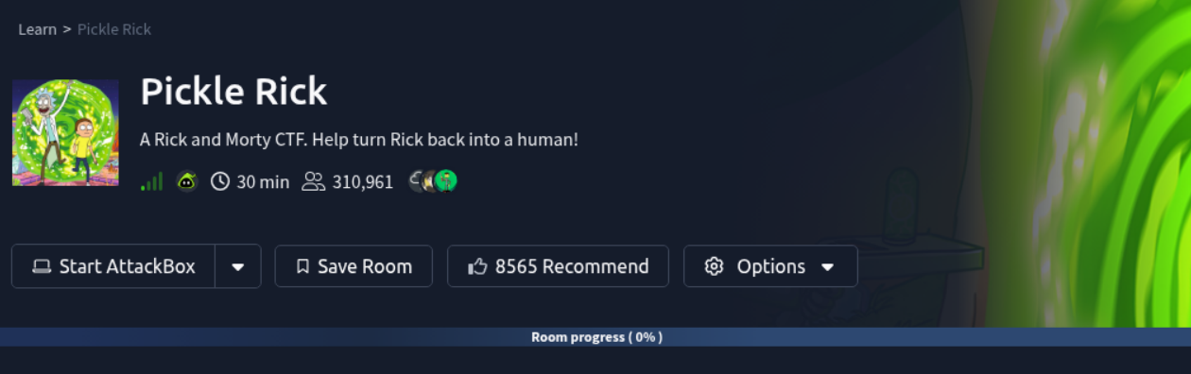
By: Malachi Plamann
Date: 11/14/2025
Link to CTF: https://tryhackme.com/room/picklerick
Difficulty: Easy

Objectives:
- What is the first ingredient?
  - mr. meeseek hair
- What is the second ingredient?
  - 1 jerry tear
- What is the last and final ingredient?
  - fleeb juice

Machine Info:
IP: 10.201.40.128
Hostname: rick.thm

Summary:
Ensuring you have proper input validation is crucial to keeping systems safe from attackers. By giving the command panel easy to bypass input restrictions and a no password root privilege, I was able to view anything on the machine by simple commands.

Walkthrough:
Let’s start with Nmap scan of the hostname to view the open ports and services
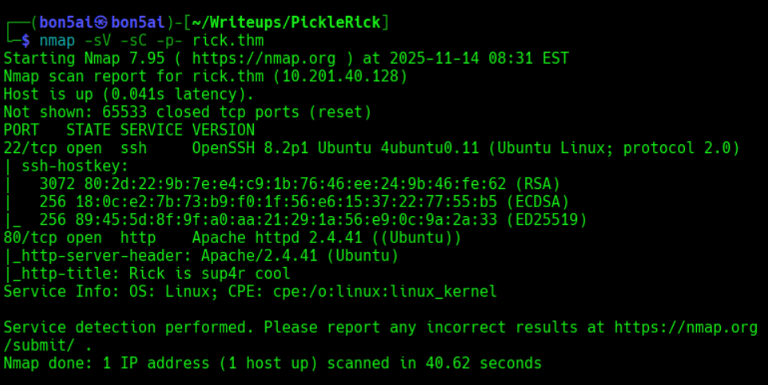
We have two open ports
22 – SSH / OpenSSH 8.2p1 Ubuntu 4ubuntu0.11
80 – HTTP / Apache httpd 2.4.41
Let’s take a look at the webpage!
We are welcomed with a basic looking homepage with no buttons or links
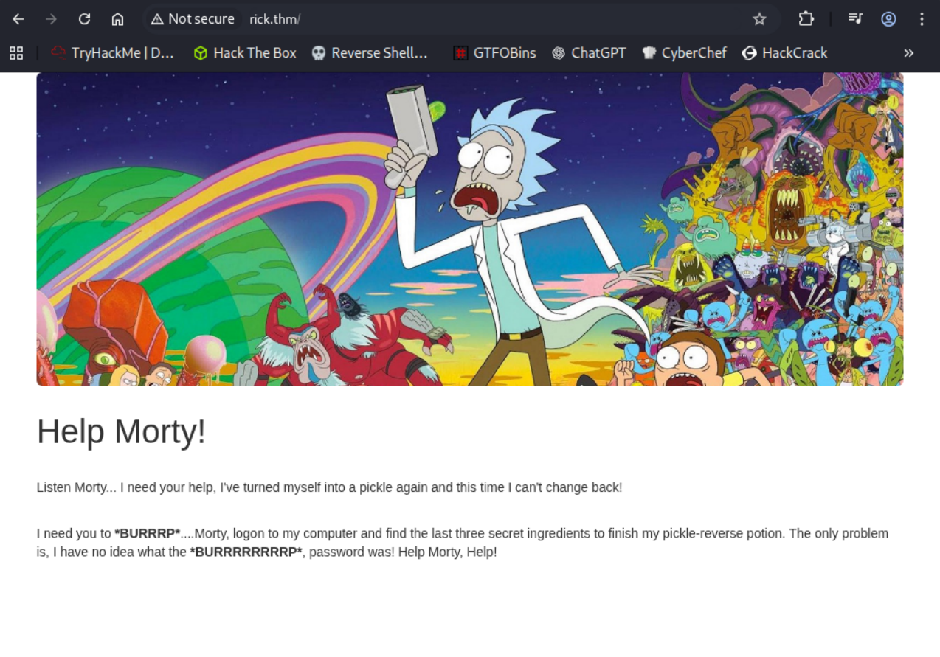
Now let’s check the page source for any hidden information
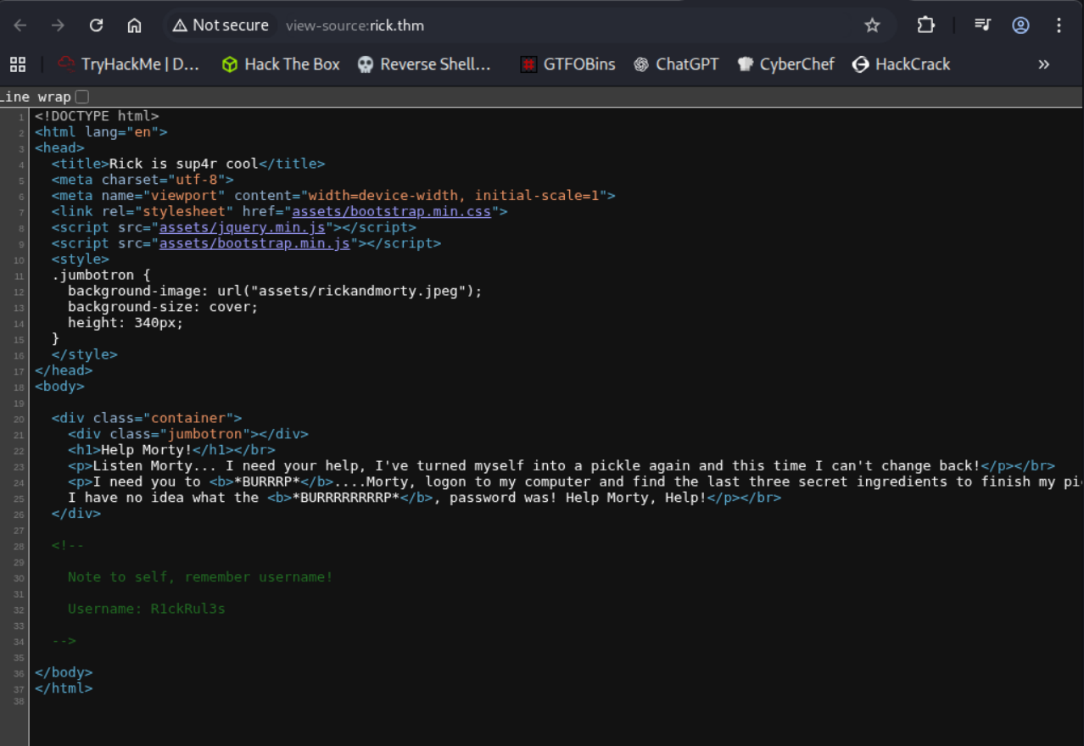
Bingo, we have a note reminding “self” of username
Username: R1ckRul3s
Let’s enumerate hidden directories using the gobuster tool
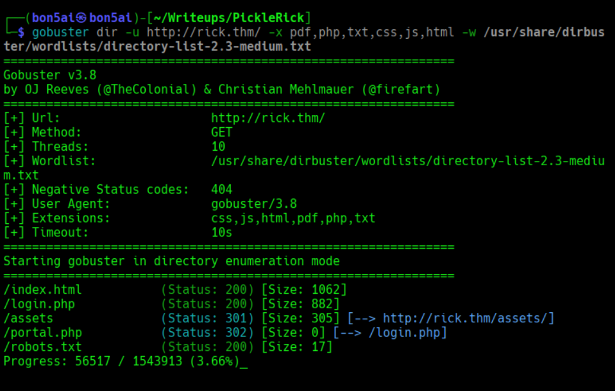
/portal.php – this is a login page asking for username and password
/robots.txt – gives us an empty page with ‘Wubbalubbadubdub’
We can try the combination of R1ckRul3s:Wubbalubbadubdub on /portal.php
This worked and allowed us to sign in
The page shows us a command panel
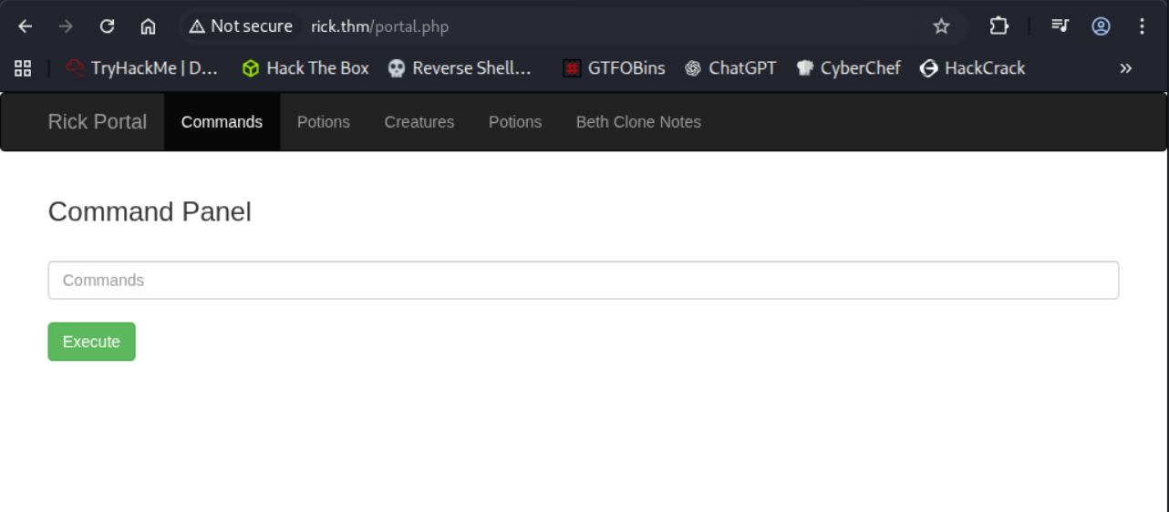
The ‘ls’ command works
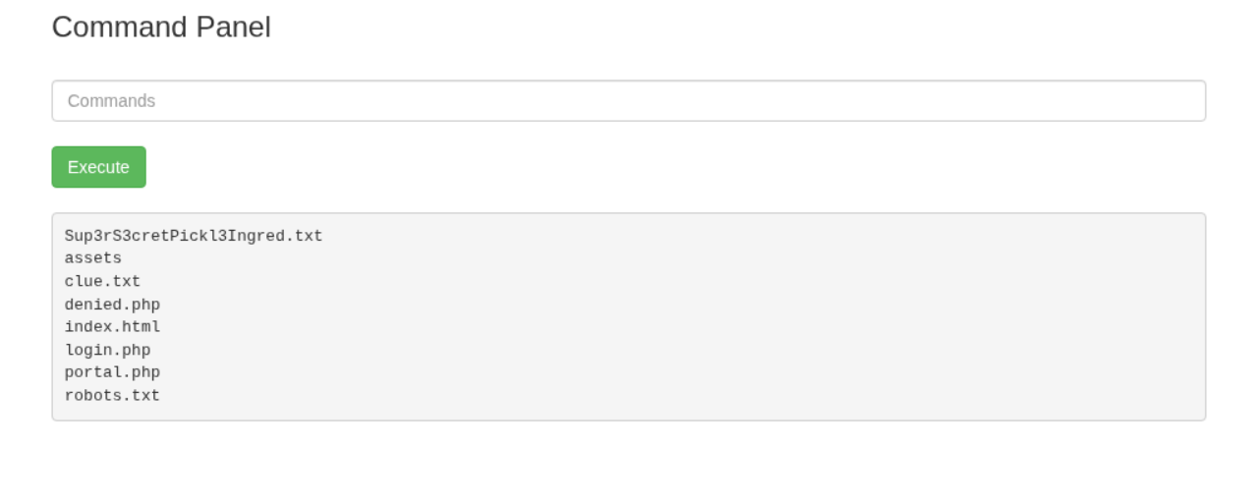
We need to read the file: Sup3rS3cretPickl3Ingred.txt
The ‘cat’ command does not work though
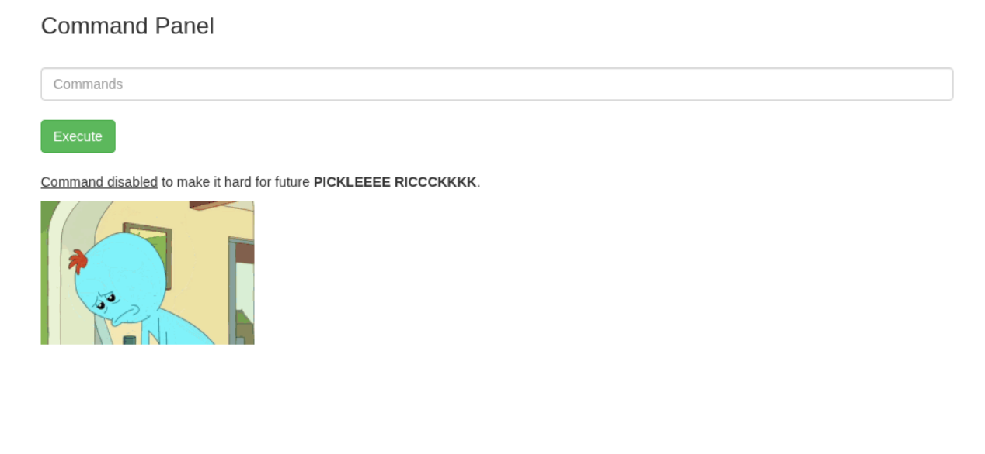
There is some sort of input validation going on to disallow the cat command
Let’s see if we can find what command validation the panel is using
When checking page source, we come across an encoded value
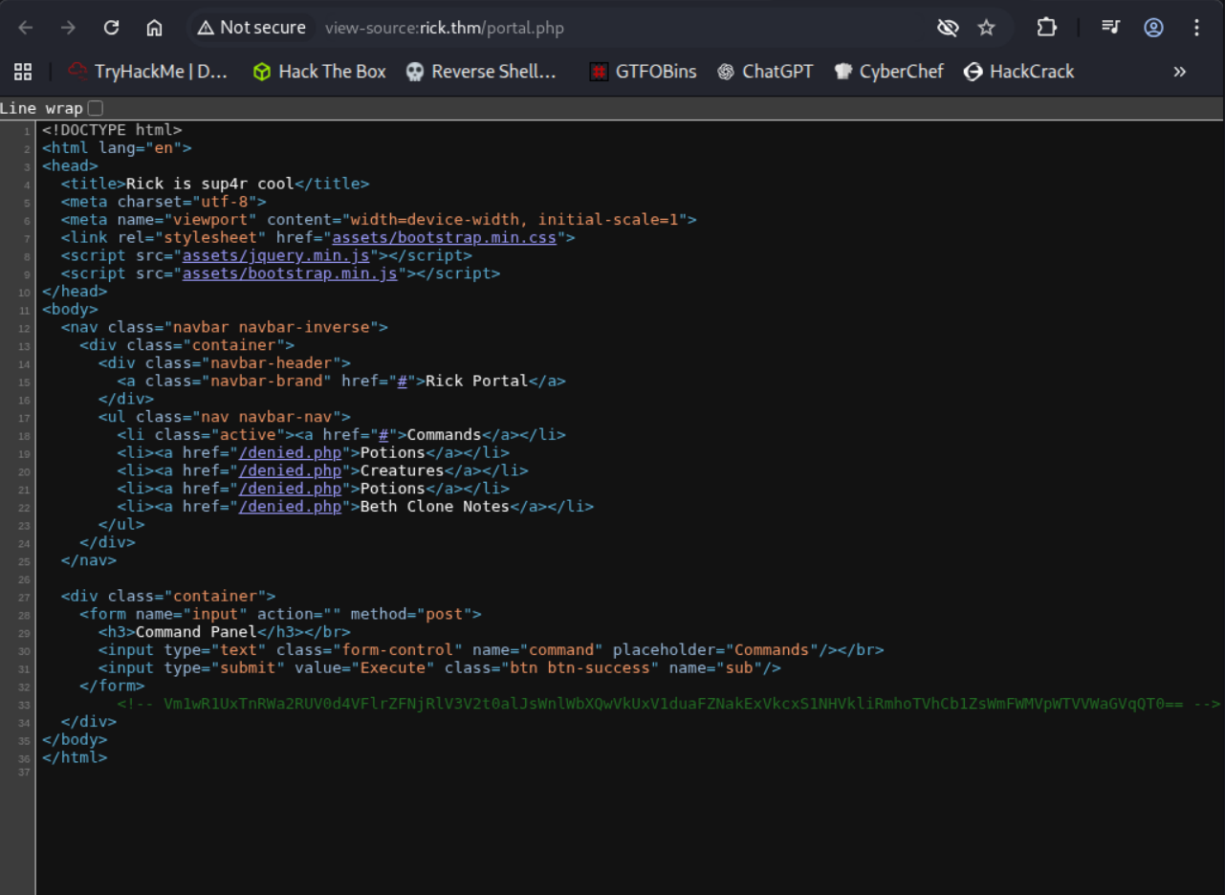
Used CyberChef to decode the base64 value and we got….
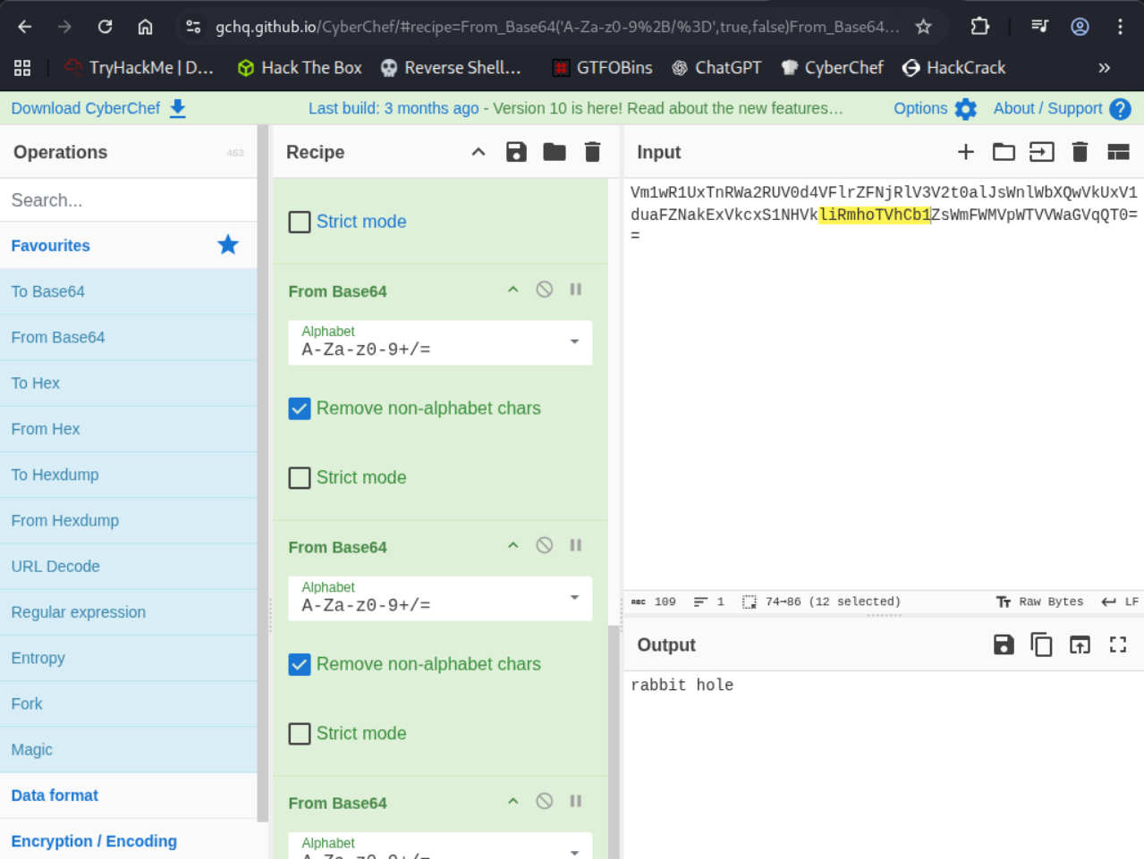
We found a rabbit hole!
Continuing onto the command panel we need to find a way to bypass the filter to read the Sup3rS3cretPickl3Ingred.txt file
I didn’t find anything showing what it’s filtering so let’s try some trial and error
Let’s try the ‘tac’ command which will display file content bottom to top
This worked!
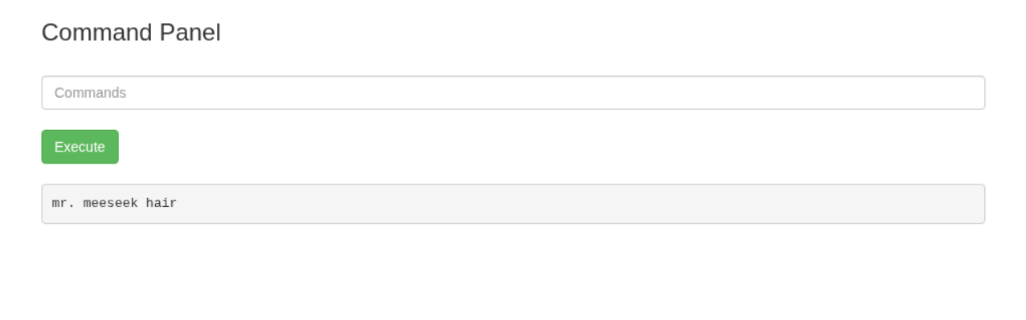
We have the first ingredient allowing us to complete objective 1!
When looking at the other panels on the Rick Portal we get this error:
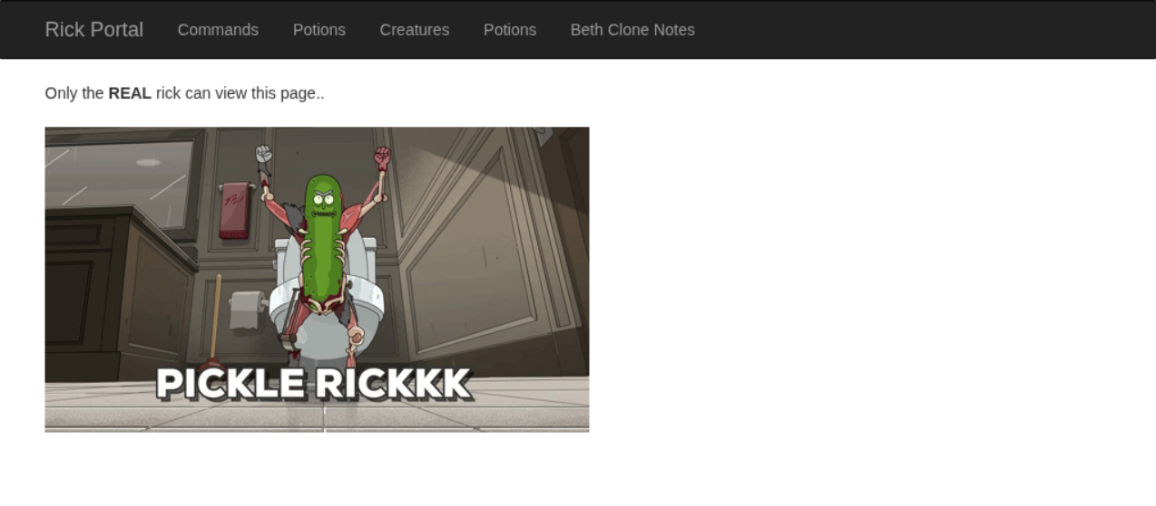
Let’s use the Burp Suite tool to intercept what the page does when loading these panels
Didn’t find anything valuable
The command panel might be something we can exploit for more information
I’m able to list directories and files by using ‘ls’
By running ‘ls /home/rick/’ we can see a file! 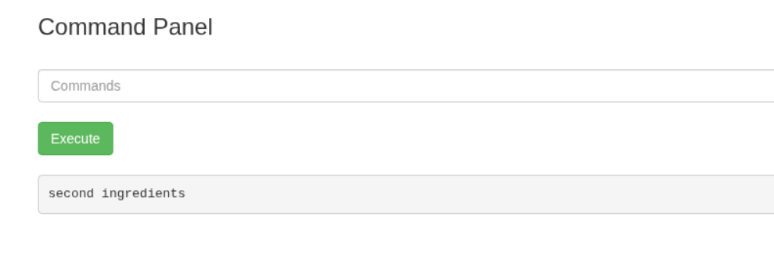
Let’s try to use the tac command to read it
We need to change the command a little bit since there’s a space here
We can use a backslash to tell the system not to run the space here as a separate argument
So the command will be 'tac /home/rick/second\ ingredients’
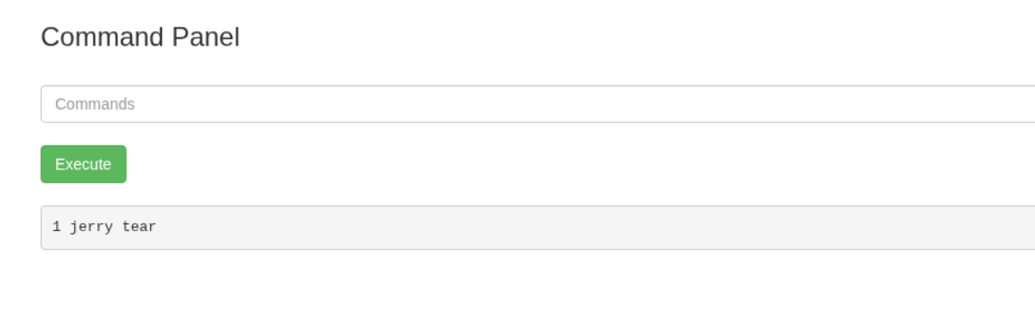
We successfully bypassed the input validation to read the second ingredient to complete objective 2!
I was curious and wanted to see what we could run as sudo from this command panel
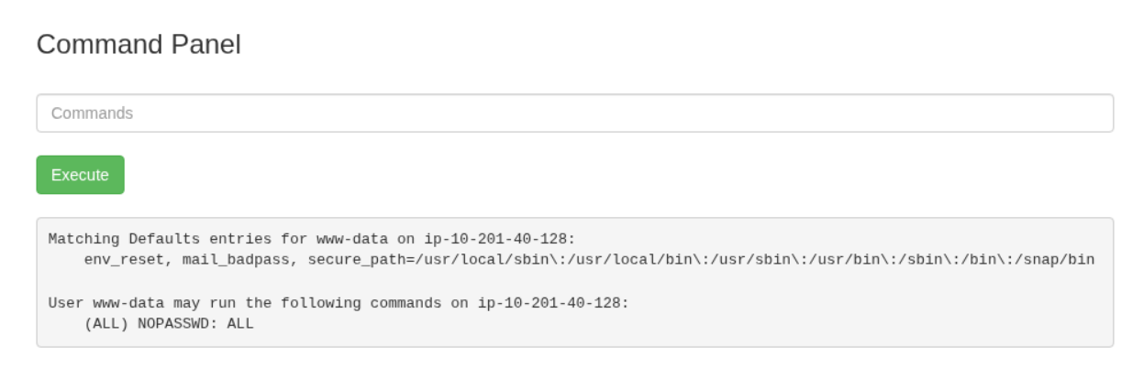
YIKES! We can run (ALL) NOPASSWD: ALL on this panel essentially making us root
Let’s run ‘sudo ls /root’ to view what’s in Root’s directory
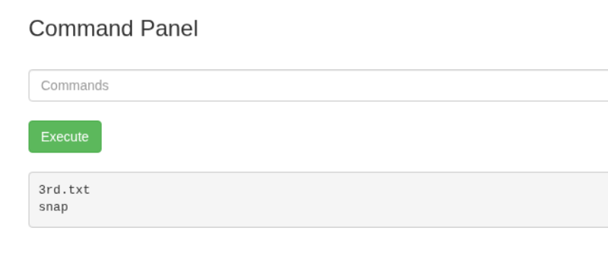
Now let’s add sudo to our tac command to read the 3rd.txt file from /root
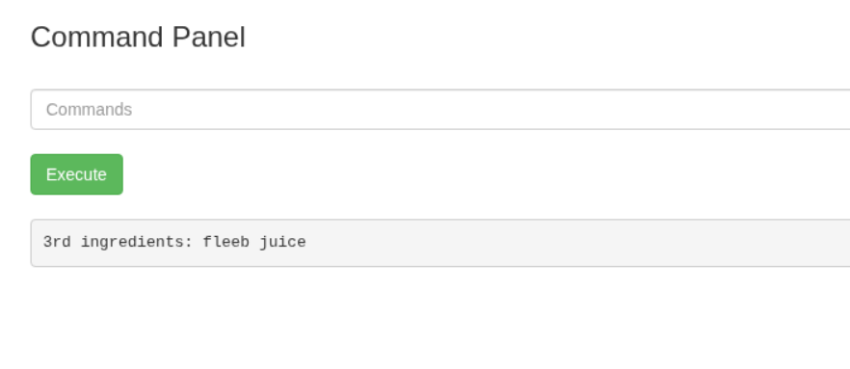
Boom! We got the 3rd and final ingredient to complete objective 3



